**LAB 3**

**1.** **Create a folder called myteam in your home directory and change its permissions to read only for the owner.**



**2.Log out and log in by another user?**

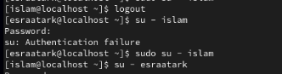

**3.** **Try to access (by cd command) the folder (myteam)**

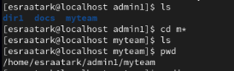

**4.Change the permissions of oldpasswd file to give owner read and writepermissions and for group write and execute and execute only for the others(using chmod in 2 different ways)**



**5.** **Change your default permissions to be as above.**

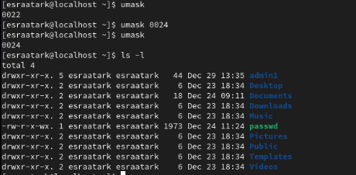

**6.** **What is the maximum permission a file can have, by default when it is just created? And what is that for directory**

For files: The maximum default permission is 666 (read and write for everyone).

* By default, files do not get the execute (x) bit.

For directories: The maximum default permission is 777 (read, write, and execute for everyone).

* The execute (x) bit allows navigation into the directory.

**7.** **Change your default permissions to be no permission to everyone then create a directory and a file to verify.**

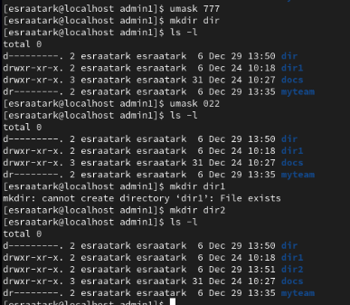

**8.** **What are the minimum permission needed for:**

**1. Copy a Directory**

* **Source Directory:**
  + **Read (r): To list the contents of the directory.**
  + **Execute (x): To traverse into the directory and its subdirectories.**

**Permissions required: r-x.**

* **Target Parent Directory:**
  + **Write (w): To create new files or directories.**
  + **Execute (x): To traverse into the directory.**

**Permissions required: wx.**

**2. Copy a File**

* **Source File:**
  + **Read (r): To read the file's content for copying.**

**Permissions required: r--.**

* **Target Parent Directory:**
  + **Write (w): To create a new file.**
  + **Execute (x): To traverse into the directory.**

**Permissions required: wx.**

**3. Delete a File**

* **Parent Directory:**
  + **Write (w): To modify the directory (remove the file entry).**
  + **Execute (x): To traverse into the directory.**

**Permissions required: wx.**

**4. Change to a Directory**

* **Directory:**
  + **Execute (x): To access the directory.**

**Permissions required: --x.**

**5. List a Directory's Content (ls Command)**

* **Directory:**
  + **Read (r): To list the contents.**
  + **Execute (x): To traverse into the directory.**

**Permissions required: r-x.**

**6. View a File's Content (more/cat Command)**

* **File:**
  + **Read (r): To read the content of the file.**

**Permissions required: r--.**

**7. Modify a File's Content**

* **File:**
  + **Write (w): To modify the content.**
  + **Read (r) (optional): If the modification requires reading the current content.**

**Permissions required: rw- or w-- (depending on whether reading is necessary).**

**9.** **Create a file with permission 444. Try to edit in it and to remove it? Note what happened.**



**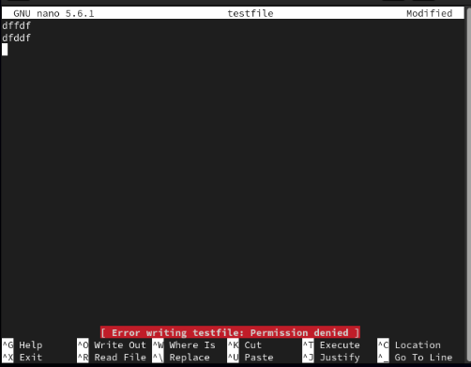  
permission denied**

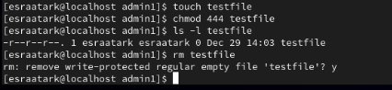

**Remove regularly**

**10. What is the difference between the “x” permission for a file and for a directory?**

**The x permission has different meanings for files and directories:**

* **For Files: It allows the file to be executed as a program or script. Without it, the file cannot be executed.**
* **For Directories: It allows traversal into the directory (e.g., using cd) and access to its contents if their names are known. Without it, the directory cannot be accessed or navigated.**

**11.**  **Using vi write your CV in the file mycv. Your CV should include your name, age, school,college, experience,...**

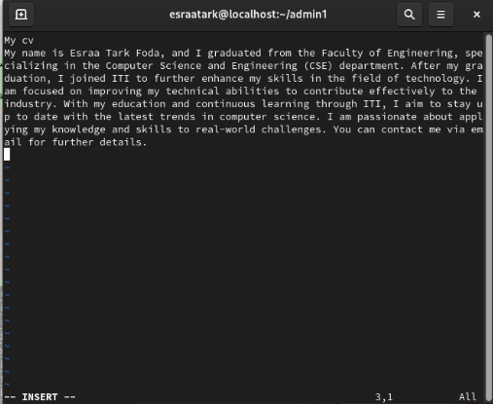





**12. Open mycv file using vi command then: Without using arrows state how to:**

**a. Move the cursor down one line at time. Press j**

**b. Move the cursor up one line at time. Press k**

**c. Search for word age /age**

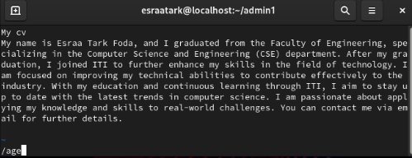



**d. Step to line 5 (assuming that you are in line 1 and file is more than 5 lines). Press 5G**

**e. Delete the line you are on and line 5. Type 5dd**

**f. How to step to the end of line and change to writing mode in one-step. Press A**

**Esraa tark foda**

**os**